CSP554—Big Data Technologies

Assignment #12

Worth: 18 !! points

Due by the start of the next class period (after Thanksgiving, 11/29)
Assignments should be uploaded via the Blackboard portal.

Exercise 1) (4 points)
Read the article “A Big Data Modeling Methodology for Apache Cassandra” available on the blackboard in the ‘Articles’ section. Provide a ½ page summary including your comments and impressions.
Apache Cassandra is a leading transactional, scalable, and highly-available distributed database. It is known to manage some of the world’s largest datasets on clusters with many thousands of nodes deployed across multiple data centers.This paper propose a novel query-driven data modeling methodology for Apache Cassandra. One of the difference from traditional database is that Cassandra database design revolves around both the application workflow and the data, and both are of paramount importance.e. Another key difference of our approach compared to the traditional strategy is that normalization is eliminated and data nesting is used to design tables for the logical data model.In this paper,the first query driven data modeling methodology for Apache Cassandra.A CQL table (hereafter referred to as a table) can be viewed as a set of partitions that contain rows with a similar structure. Queries over tables are expressed in CQL, which has an SQL-like syntax.Designing a Cassandra database schema requires not only understanding of the to-be-managed data, but also understanding of how a data-driven application needs to access such data. Various Data modelling principles are DMP1 (Know Your Data),DMP2 (Know Your Queries),DMP3 (Data Nesting) and DMP4 (Data Duplication).Based on the data modeling principles, there are five mapping rules that guide a query-driven transition from a conceptual data model to a logical data model.They are MR1 (Entities and Relationships),MR2 (Equality Search Attributes),MR3 (Inequality Search Attributes),MR4 (Ordering Attributes) and MR5 (Key Attributes).Based on the above mapping rules, we design mapping patterns that serve as the basis for automating Cassandra database schema design.The final step of our methodology is the analysis and optimization of a logical data model to produce a physical data model.This paper propose a novel visualization technique, called Chebotko Diagram, which presents a database schema design as a combination of individual table schemas and query-driven application workflow transitions.
The following instructions were provided by Prof. Adam McElhinney…
For the remaining exercises you will use an instance of the Cassandra database that you set up in the hadoop sandbox in the Azure cloud. The instructions for installing it and starting the Cassandra shell are as follows:
Open a terminal window and log on to maria_dev. Enable python 2.7:
scl enable python27 bash
export LD_LIBRARY_PATH=/opt/rh/python27/root/usr/lib64/:$LD_LIBRARY_PATH

Verify your Python version is 2.7:
python –version
Install Java version 8 (you might need to supply your root password):
sudo yum install java-1.8.0-openjdk
Check the java version:
java -version
Install wget (you might need to supply your root password):
sudo yum install wget
Download the tarball:
wget http://apache.osuosl.org/cassandra/3.11.3/apache-cassandra-3.11.3-bin.tar.gz
Unpack the tarball:
tar -xvf apache-cassandra-3.11.3-bin.tar.gz
Start Cassandra in the background. This could take 5-10 minutes:
apache-cassandra-3.11.3/bin/Cassandra
Open another terminal window and log on to maria_dev again. Verify Cassandra working:
apache-cassandra-3.11.3/bin/nodetool status
Start the Cassandra shell cqlsh:
apache-cassandra-3.11.3/bin/cqls

Note: after you finish this entire assignment you could clean up Cassandra as follows (in the shell):
DROP TABLE emp;
Also drop any other tables you have created.
DROP KEYSPACE dev;
Also drop any other key spaces you have created.

To stop the Cassandra server (in a terminal window):
(Get the pid)
ps ax | grep CassandraDaemon
kill pid

Exercise 2) (2 points)
The following instructions were provided by Prof. Adam McElhinney…
Follow the instructions to create and explore a small Cassandra database…

Create a keyspace:
create keyspace dev with replication = {'class':'SimpleStrategy','replication_factor':1};
Within the dev keyspace, create a table to hold employee data:
use dev;

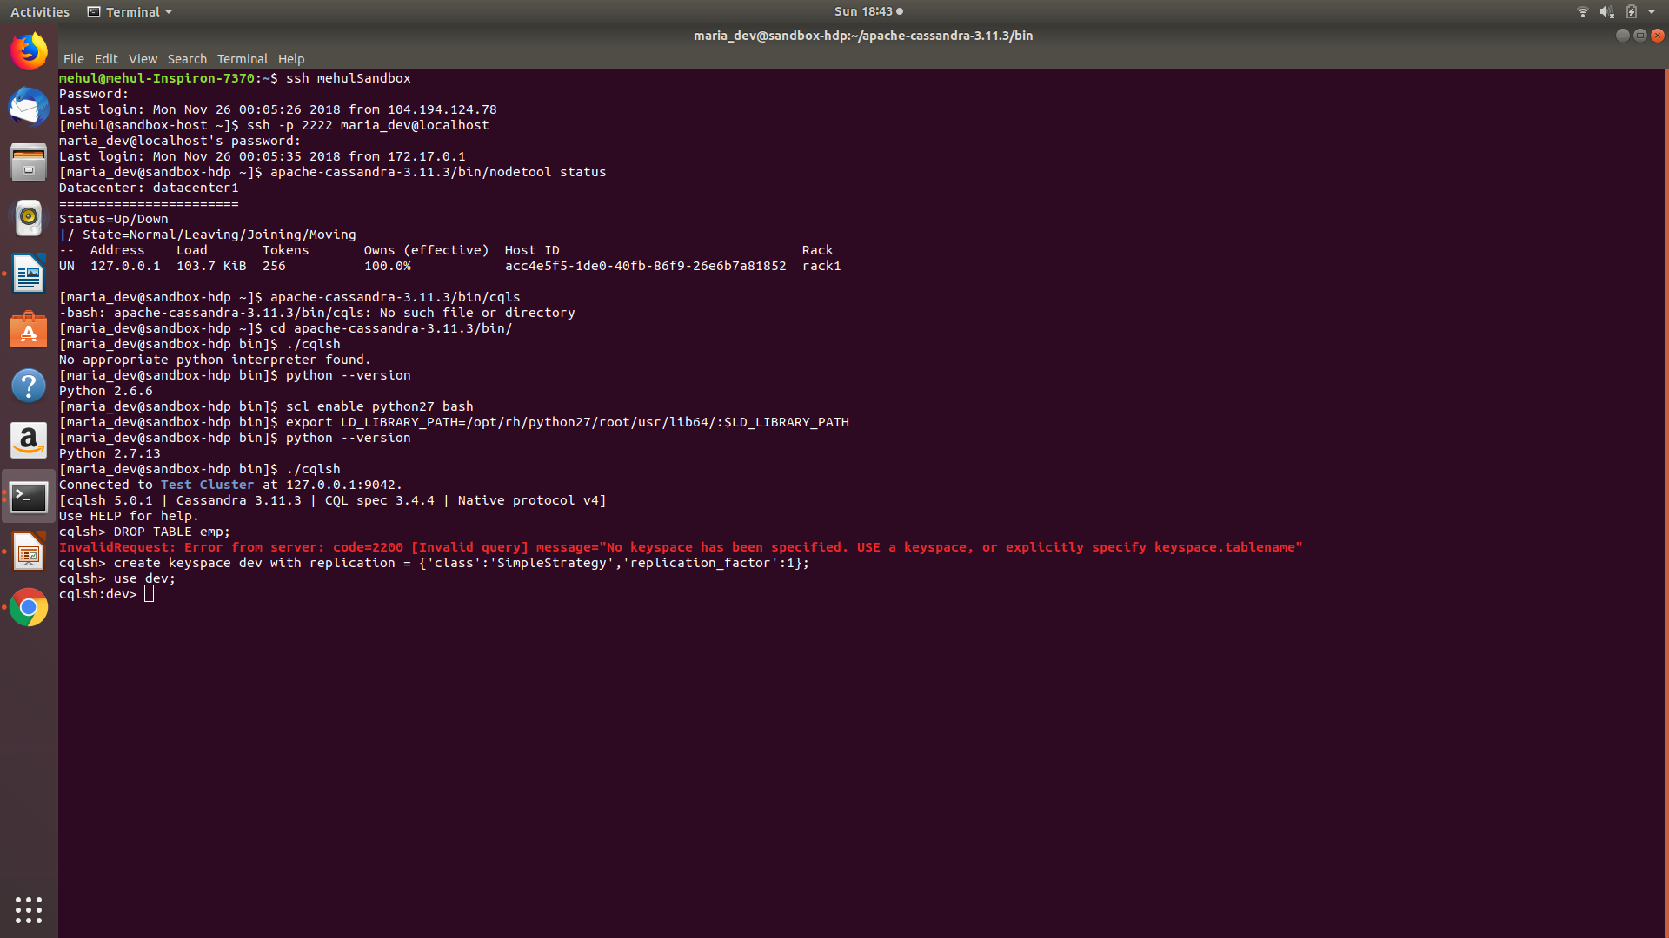
create table emp (empid int primary key, emp_first varchar, emp_last varchar, emp_dept varchar);
Let's put some data into there:
insert into emp (empid, emp_first, emp_last, emp_dept) values (1,'fred','smith','eng');

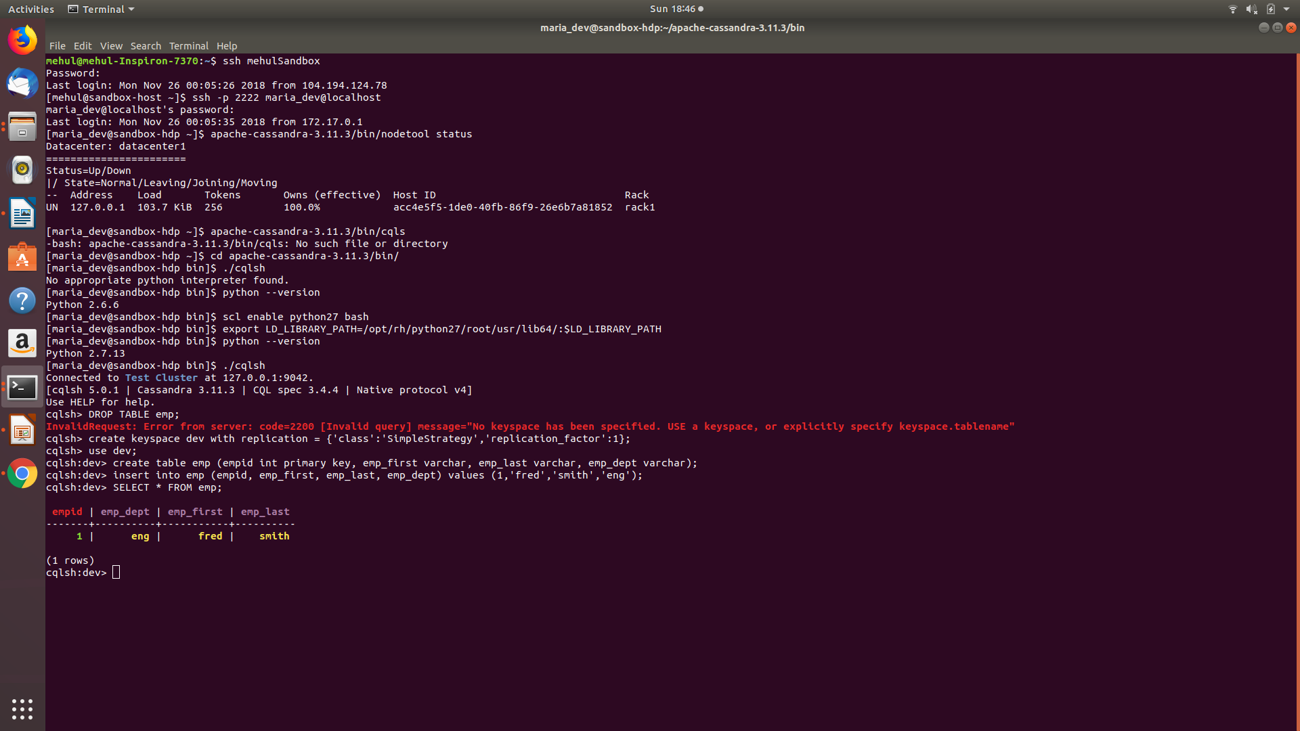
Let's modify that data also:
update emp set emp_dept = 'fin' where empid = 1;
Now let's view that data:
SELECT * FROM emp;
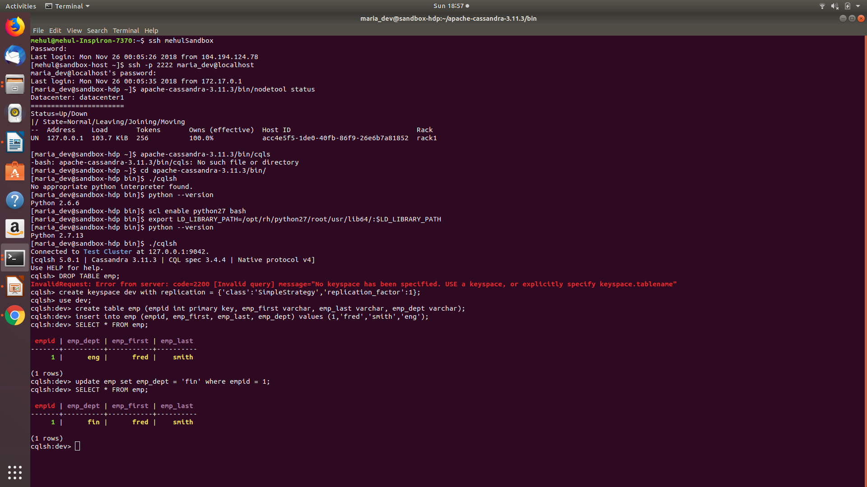
As part of the answer to this exercise provide a screen shot of the output of the above select statement.
Try a where clause:
select * from emp where empid = 1;
As part of the answer to this exercise provide a screen shot of the output of the above select statement.
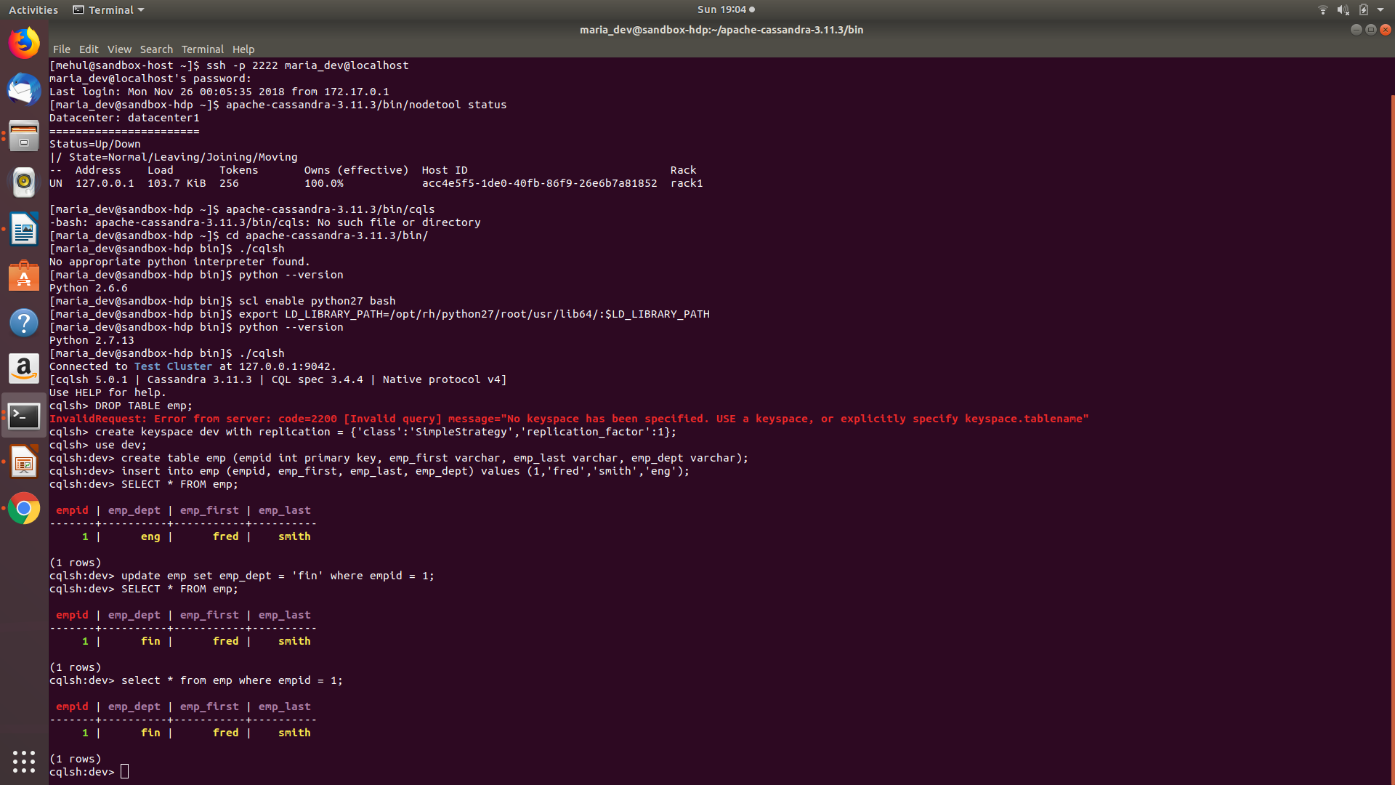
Let's insert some more data:
insert into emp (empid, emp_first, emp_last, emp_dept) values (2,'jamie','jones','eng');
insert into emp (empid, emp_first, emp_last, emp_dept) values (3,'kate','stevens','hr');
insert into emp (empid, emp_first, emp_last, emp_dept) values (4,'pat','smith','eng');
SELECT * FROM emp;
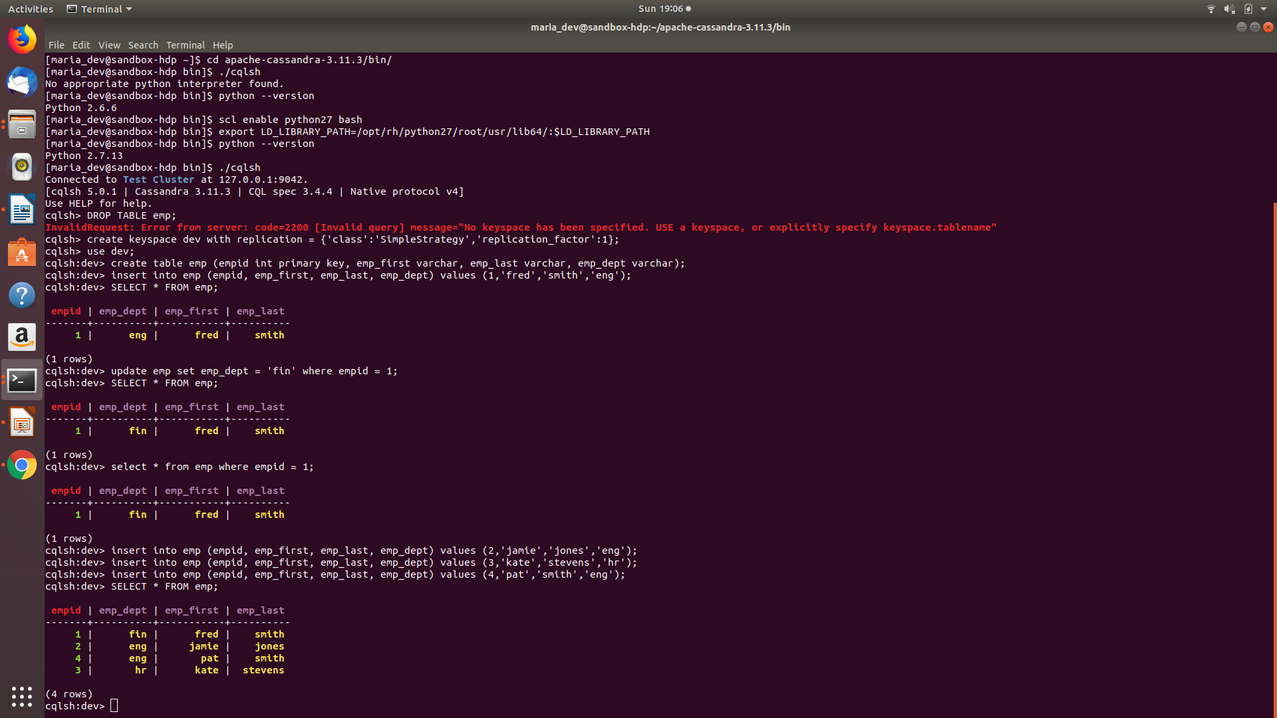
As part of the answer to this exercise provide a screen shot of the output of the above select statement.

Let's view only the people from engineering:
SELECT * FROM emp WHERE emp_dept = 'eng';

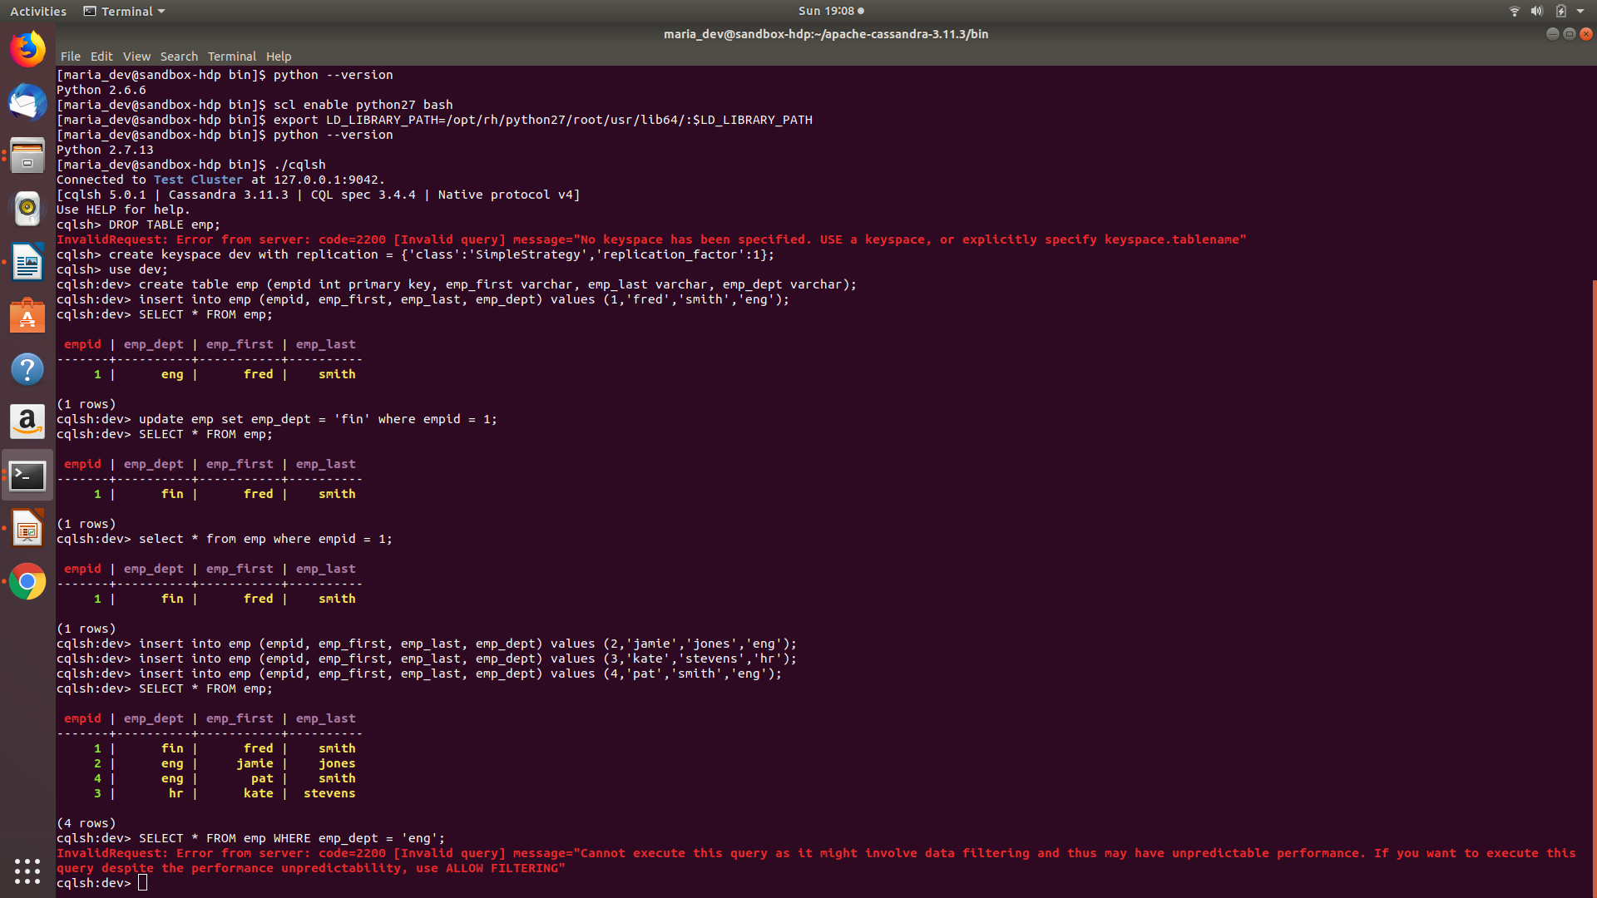
This gives an error because we need a secondary index:
CREATE INDEX emp_dept ON dev.emp(emp_dept);
Now try the query:
SELECT * FROM emp WHERE emp_dept = 'eng';
As part of the answer to this exercise provide a screen shot of the output of the above select statement.
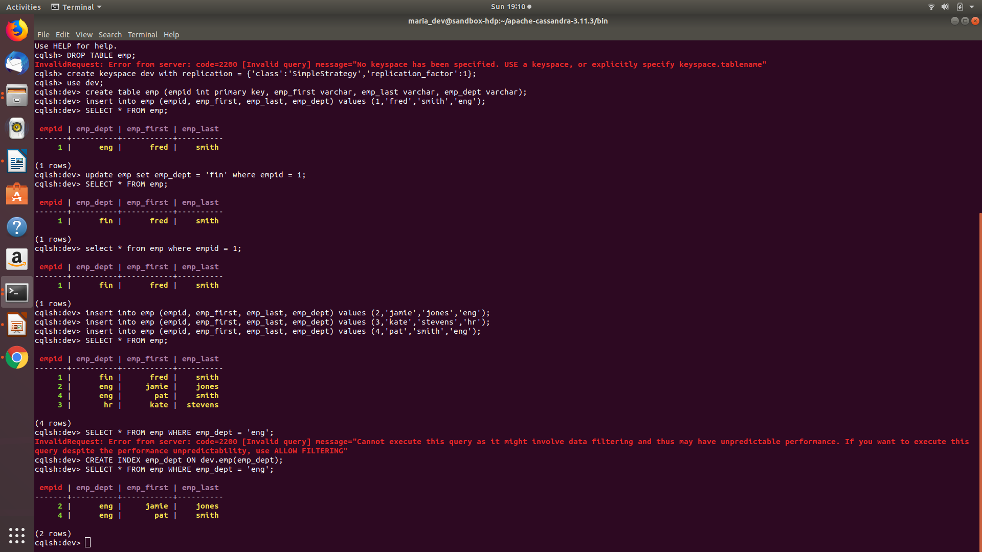
Exercise 3) (3 points)
Now create a file in your working directory called ex3.cql. In this file write the command to create a table named ‘Music’ with the following characteristics:
Attribute Name | Attribute Type | Primary Key / Cluster Key
artistName | text | Primary Key
albumName | text | Cluster Key
numberSold | int | Non Key Column
cost | int | Non Key Column

Execute ex3.cql. Then execute the shell command ‘DESCRIBE TABLE Music’ and include the output as the result of this exercise.
Command:
create table music (artistName text , albumName text ,numberSold int, cost int, PRIMARY KEY(artistName, albumName));
executed command = SOURCE ‘~/ex3.cql’

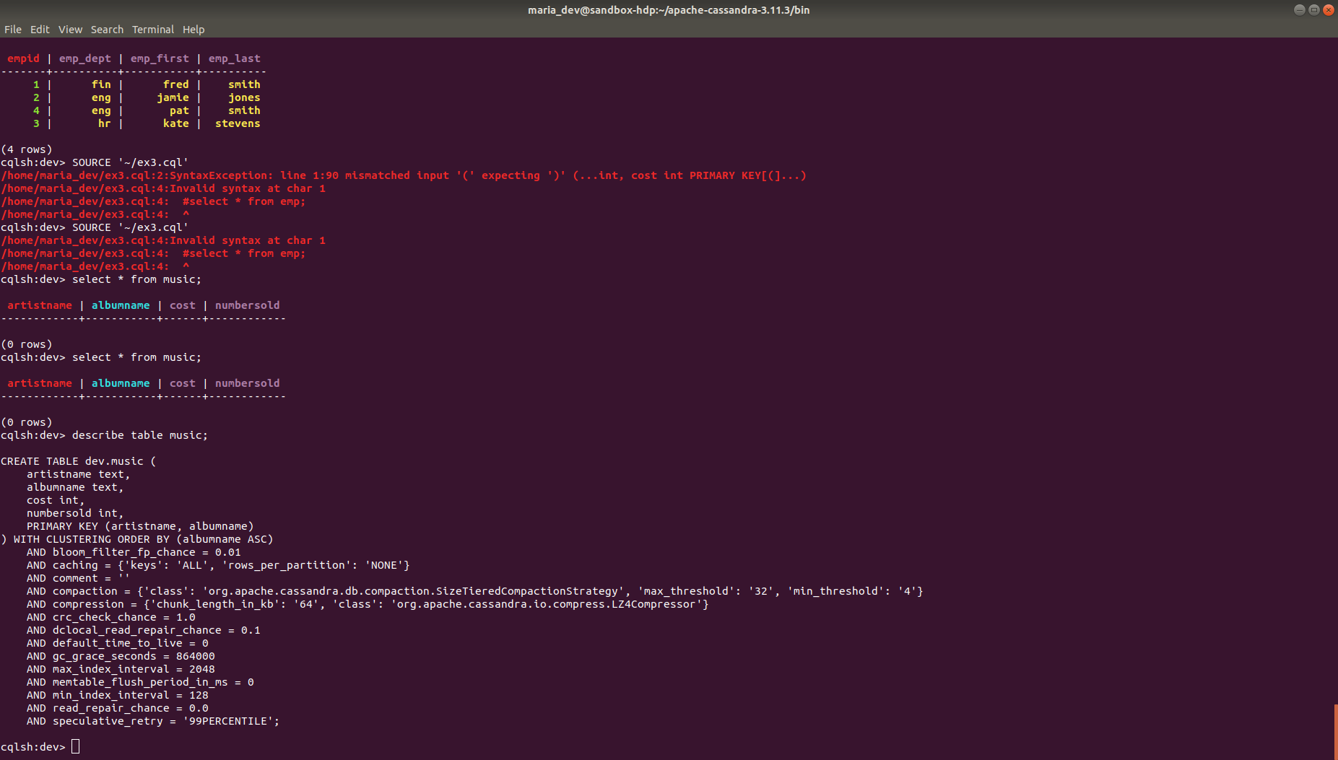
Exercise 4) (3 points)
Now create a file in your working directory called ex4.cql. In this file write the commands to insert the following records into table ‘Music’…
artistName | albumName | numberSold | cost
Mozart | Greatest Hits | 100000 | 10
Taylor Swift | Fearless | 2300000 | 15
Black Sabbath | Paranoid | 534000 | 12
Katy Perry | Prism | 800000 | 16
Katy Perry | Teenage Dream | 750000 | 14

a)Execute ex4.cql. Provide the content of this file as the result of this exercise.
ex4.cql file command:
insert into music(artistName,albumName,numberSold,cost) values('Mozart','Greatest Hits',100000,10);
insert into music (artistName,albumName,numberSold,cost) values('Taylor Swift','Fearless',2300000,15);
insert into music (artistName,albumName,numberSold,cost)values('Black Sabbath','Paranoid',534000,12);
insert into music (artistName,albumName,numberSold,cost)values('Katy Perry','Prism',800000,16);
insert into music (artistName,albumName,numberSold,cost)values('Katy Perry','Teenage Dream',750000,14);

executed script: SOURCE ‘~/ex4.cql’
b) Execute the command ‘SELECT * FROM Music;’ and provide the output of this command as another result of the exercise.

Command : SELECT * FROM Music;

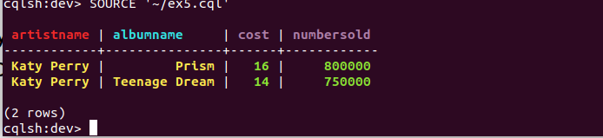
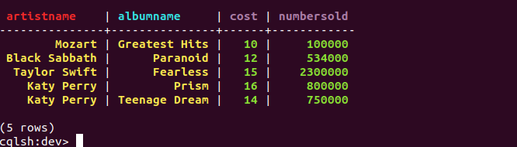
Exercise 5) (3 points)
Now create a file in your working directory called ex5.cql. In this file write the commands to query only Katy Perry songs. Execute ex4.cql. Provide the content of this file and result of executing this file as the result of this exercise.
Ex5.cql file script:
select * from music where artistName = 'Katy Perry';
executed commands: SOURCE ‘~/ex5.cql’
Exercise 6) (3 points)
Now create a file in your working directory called ex6.cql. In this file write the commands to query only albums that have sold 700000 copies or more. Execute ex6.cql. Provide the content of this file and the result of executing this file as the result of this exercise.
select * from music where numbersold > 700000 allow filtering;
executed commands: SOURCE ‘~/ex6.cql’
